Project Report:
Title:
End-to-End Hospital Financial Toxicity Project
Role: Aspiring Data Analyst

Hospital Financial Toxicity

1. Executive Summary
Healthcare providers are facing a hidden crisis: Patients abandoning treatment against medical advice (LAMA) due to catastrophic out-of-pocket (OOP) expenses. While the Ayushman Bharat scheme provides a ₹5 Lakh insurance cap for Below Poverty Line (BPL) families, hospital operations teams lacked visibility into when and why patients were breaching this cap.
This project involved engineering a full-scale diagnostic analytics pipeline and interactive dashboard to map the exact intersection of clinical risk, patient demographics, and financial toxicity. The resulting model successfully identified key drivers of cap breaches and proved that BPL utilization rates remain statistically independent across all admission types, allowing hospital administration to deploy targeted financial counseling before patients abandon care.

2. Problem Statement:
The initial stakeholder request focused on high 30-day readmission rates among patients with complex comorbidities. After performing exploratory analysis on 120,000+ admissions, the overall readmission rate was found to be just 0.52% — and 0% in the highest-risk cohort, making readmission prevention a statistically weak focus area.
The dominant pattern identified was severe financial toxicity: a concentrated group of 0.27% of admissions frequently breached the Ayushman cap, generating ₹12.39 crore in calculated out-of-pocket burden. The problem statement was accordingly refined to focus on identifying high-cost, high-risk patient cohorts — ensuring the analysis remained grounded in what the data actually revealed.

2. Tech Stack:
- Source Data: India Hospital Readmission & Discharge Dataset (Kaggle).

- Link: https://www.kaggle.com/datasets/digutlaranjithkumar/india-hospital-readmission-dataset-20152024

Language & Database: SQL Server Express (T-SQL), SSMS.
- Data Engineering (ETL): BULK INSERT for data ingestion, Medallion Architecture Schema Design, Data Quality Assurance (DQA).
- Data Modeling: Dimensional Modeling (Fact and Dimension views), Handling Datatype Collisions, and Anomaly Cleansing.
- Advanced Analytics:
- Common Table Expressions (CTEs), Scalar Subqueries
- Window Functions (ROW_RANK (), LAG(), SUM() OVER())
- String Functions (TRIM(), SUBSTRING(), CHARINDEX())
- TRY_CAST(), Complex Joins, complex CASE statements.
- Visualisation: Created interactive, analytical and customized graphical user interface dashboards in PowerBI for deep insights and effective decision making.

3. Data Architecture & Engineering
To ensure enterprise-grade data integrity and scalability, I designed a rigorous Medallion Architecture Pipeline (Bronze, Silver, Gold) using T-SQL, moving away from fragile flat-file reporting.
3.1. Bronze Layer (Raw Ingestion)
- Ingested 120,000+ raw hospital admission records.
- Retained historical fidelity without applying transformations, ensuring a pure source of truth.
- Executed rigorous DQA (Data Quality Assurance) using SQL.
3.2. Silver Layer (Transform)
- Dealing with the anomalies, inconsistencies and outliers that we found in the DQA.
Handled:
- Discarded the readmitted_7d and readmitted_30d column from the bronze layer due to flag errors.
- Then recreated and calculated manually using DATEDIFF().
- Separated cost_category column:

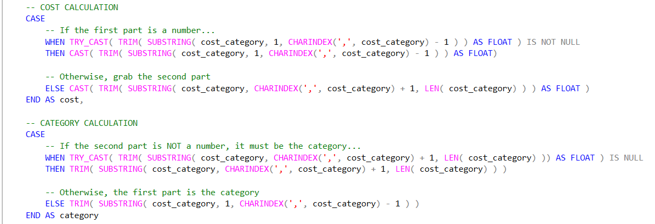

- Handled duplicates in the patient table:
- Performed Standardization.
Medallion Architecture:
- Preserves raw data fidelity in the Bronze layer — the original source is never overwritten and remains available for reprocessing if analytical requirements change
- The layered structure naturally supports ETL and report automation, as each layer has a clearly defined transformation contract
- Separating raw ingestion, cleansing, and modeling makes the pipeline fully auditable — any data quality issue can be traced to the exact layer where it was introduced
ML-Ready Feature Engineering:
- Explicit binary flag columns were engineered for admission type, discharge type, and cap breach status
- While these flags serve the current dashboard, they were deliberately structured to support future predictive models — enabling the hospital to identify at-risk patients before cap breach occurs, rather than reporting on it after the fact.
Why Average Cost over Total OOP:
- Total OOP reflects hospital-level revenue dynamics and is heavily skewed by admission volume
- Average Patient Cost isolates the individual patient experience — the correct unit of analysis when the core question is what does financial toxicity feel like for a single patient, not how much did the hospital collect overall.

Challenges:
The Filter Context Trap
Building the Cap Breach Rate KPI revealed an unexpected problem — the metric was displaying 137%, which is mathematically impossible for a rate. After investigation, the root cause was a mismatch in how DAX was evaluating the measure: the numerator was correctly responding to the active visual filter, but the denominator was locked to the static BPL patient count regardless of what the user selected on the dashboard.
The fix was straightforward once the cause was clear — replacing the rigid denominator with total admissions, which naturally respects whatever filter context the user applies:
exceeded_cap_rate = DIVIDE([total_cap_exceeded], [total_admissions])
This single change meant the KPI now recalculates correctly whether a user is viewing the entire hospital population or drilling into a specific disease and demographic combination.

The 30-Day Readmission Problem
Calculating readmissions sounds simple — just check if a patient returned within 30 days of their last discharge. The complication is doing this across 120,000 rows. Attempting this calculation in DAX using iterative functions like EARLIER() or nested FILTER statements creates serious memory pressure and slows the entire report down.
The better approach was to solve this problem before the data ever reached Power BI. During the Silver-to-Gold transformation in SQL, I used the LAG() window function — partitioned by patient and ordered by admission date — to calculate days since last discharge at the database level. The result was stamped as a simple 1/0 flag directly into the fact table.
What was previously an expensive, slow calculation became a lightweight SUM() in Power BI — and the readmission KPI now filters instantly across any disease or demographic combination.

The Many-to-Many Disease Problem
Healthcare data has an inherent structural challenge — patients rarely present with a single diagnosis. A patient admitted for Sepsis may also have COPD. If both diagnoses are joined to the same admission row using a standard relational join, the database duplicates that row, and suddenly 120,000 admissions become 200,000. Every financial metric breaks.
The solution was to strictly enforce the grain of the fact table: one row equals one hospital admission, no exceptions. The primary diagnosis was used as the main dimensional key, keeping disease-level analysis possible without allowing comorbidities to inflate the row count.
This decision is what keeps the ₹48.17K Average Patient Cost mathematically sound — regardless of how many conditions a patient presents with or how many slicers a user activates simultaneously.

3.3. Gold Layer (Analytics ready data)
- Modeled the cleansed data into a highly optimized Star Schema, separating quantitative metrics into Fact tables (fact_admissions) and descriptive attributes into Dimension tables
(dim_patients, dim_diagnoses, dim_bridge_admission_diagnoses, dimDate, dim_admission_profile.
- bridge_admission_diagnoses: To ensure the dimension and fact table granularity, this table works as a bridge between dim_diagnoses and fact_admissions table. Because the diagnoses table contain each diagnosis even the non-primary diseases in separate rows. It has all the diagnoses primary and non-primary against every admission id.
Diagram:
Created the data modeling diagram in Power BI after extracting the analytics ready data from the SQL Server Express Database.

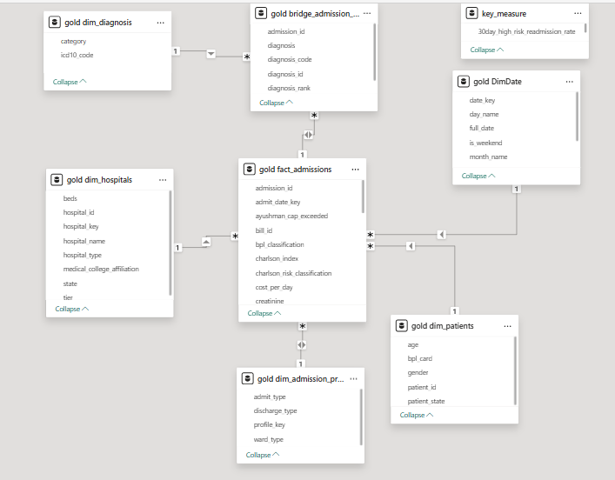
4.Dashboard Creation
Created an interactive dashboard by using Power Query, DAX and Visuals to deliver the insights through KPIs, charts and slicers:
- KPIs:
- Total Admissions
- 30Day-Readmission Rate
- Patient Cost
- Cap Breach Rate
- BPL Rate

- Horizontal Bar Chart: What are the top diseases with highest average patient cost?
- Column Bar Chart: Population distribution, BPL & Non-BPL against Charlson Risks.
- Column Bar & Line Chart: Charlson Risks with the magnitude of average patient cost that force patients to leave before proper recovery.
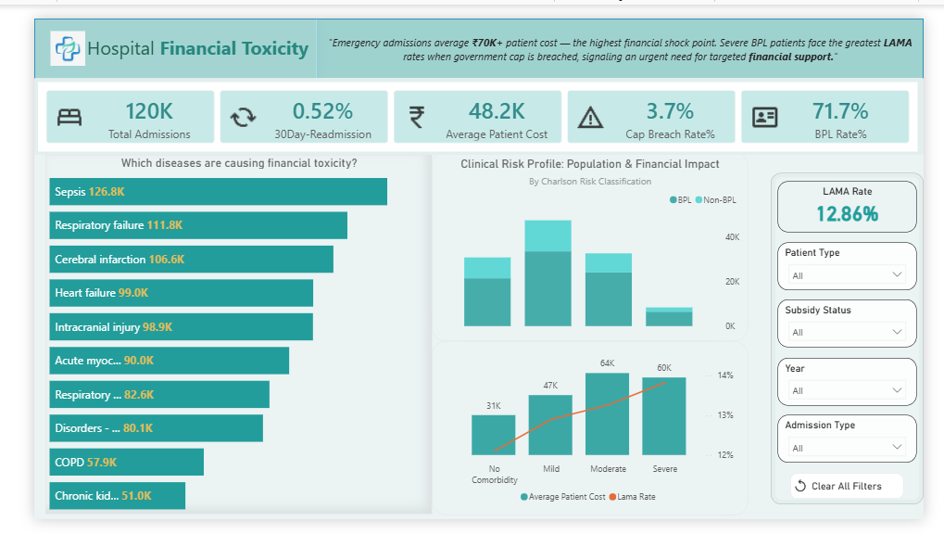

5. Key Insights:
Financial Impact:
- Emergency admissions average ₹70K+ in patient cost and cap breach rate of 6.6% twice of the overall average breach rate, representing the highest immediate financial shock point.
- Severe and Moderate risk BPL patients face the highest LAMA rates the exact moment the government cap is breached.
- Diseases like Sepsis, Respiratory and Cerebral infarction contributes the most to patient-out-of-pocket in emergency cases.
- OPD and Elective admissions average ₹16K in patient cost, representing less financial point. Still this amount is unbearable for the Below Poverty Line patients.
- In both admissions, the diseases COPD, Alcoholic Liver and Chronic Kidney are contributing the most to financial toxicity.
- Also, the severe Charlson risk is nearly same in both admission types with highest average patient and LAMA rate cost among other risks.
The data proves that clinical severity combined with the sudden loss of subsidy creates an unmanageable financial toxicity loop.
BPL Patient Utilization Across Admission Types:
A significant discovery was the consistency of the BPL patient ratio across all admission categories. Across 120k admissions, the BPL rate remained stable at 71 %, regardless of whether the admission was an Emergency, Elective, or OPD visit.
- The Observation: The BPL proportion remained virtually identical across all admission types, suggesting that financial status does not influence how patients access the hospital.
- Business Translation: BPL patients are not avoiding out-of-pocket departments like OPD. They trust and utilize the hospital across all tiers of care at the same rate as the broader hospital population — confirming that the hospital serves as the primary healthcare provider for this demographic, regardless of cost exposure.

6. Strategic Recommendations
Based on the diagnostic data, I recommend the hospital operations team implement the following structural changes:
- Proactive Financial Counseling: Trigger mandatory financial counseling for any BPL patient admitted under a "Severe" mode Charlson Risk Classification before they exhaust their ₹5 Lakh cap, as the data shows this specific cohort has the highest propensity for LAMA.
- Emergency Intake Subsidies: Because Emergency admissions create the largest immediate financial shock, operations should investigate setting up an internal micro-subsidy or payment plan option explicitly for non-BPL patients facing sudden Emergency intake.
- Cap breach early warning system.
Limitation:
The dataset did not contain an explicit column for actual patient debt or confirmed out-of-pocket payments. As a result, the financial burden metric used throughout this analysis represents the uncovered cost — the gap between total treatment cost and the government subsidy cap — rather than the amount definitively paid by the patient.
This distinction matters: it remains unknown whether the hospital absorbed these excess costs internally or whether they were passed directly to the patient. The analysis cannot confirm which party ultimately bore the financial burden.
However, this limitation does not diminish the value of the findings. Regardless of who covered the gap historically, the hospital has no systemic visibility into when patients are approaching their coverage limit — and the data clearly shows that the highest-risk patients are abandoning care at precisely that moment. The purpose of this analysis is to enable proactive intervention before that situation occurs, making the uncovered cost gap a valid and actionable proxy for financial risk — even in the absence of confirmed debt data.

